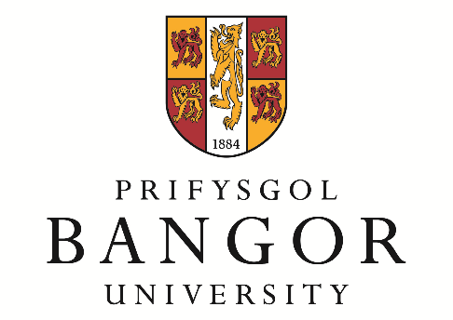

**Workshop**

**50 years of research at the**

**Institute of European Finance**

**(IEF)**

**A celebration of Emeritus Professor Phil Molyneux contribution to banking and economics research**

**Bangor Business School**

**Bangor University**

**22 – 23 November 2023**

|  |  |  |
| --- | --- | --- |
| **PROGRAMME** | | |
| WEDNESDAY | | |
| Noon to 1:45pm | Buffet lunch and registration | |
| 1:45pm to 2:00pm | Welcome | |
| 2:00pm to 3:00pm | KEYNOTE SPEAKER  Professor Claudia Girardone | |
| 3:00pm to 3:30pm | Coffee/ tea break | |
| 3:30pm to 5:00pm | Parallel Session (Wednesday) | |
|  | Regulatory Workshop: Banks Response to Regulatory and Recent Economic and Political Shocks | Parallel Session (2)  Parallel Session (3) |
|  |  | Parallel Session (4) |
| 5:00pm to 7:00pm | Networking | |
| 7:00pm till late | Dinner at the Management Centre  *A celebration of Emeritus Professor Phil Molyneux contribution to banking and economics research* | |
| THURSDAY | | |
| 9:00am to 10:30am | Parallel Session (Thursday) | |
|  | Parallel Session (1) | Parallel Session (2) |
|  | Parallel Session (3) | Parallel Session (4) |
| 10:30am to 11:00am | Coffee/ tea break | |
| 11:00am to 12:00am | KEYNOTE SPEAKER (2)  Professor Santiago Carbó Valverde | |
| Noon to 12:15pm | Closing remarks | |
| 12:15pm to 1:30pm | Buffet lunch | |
|  |  |  |