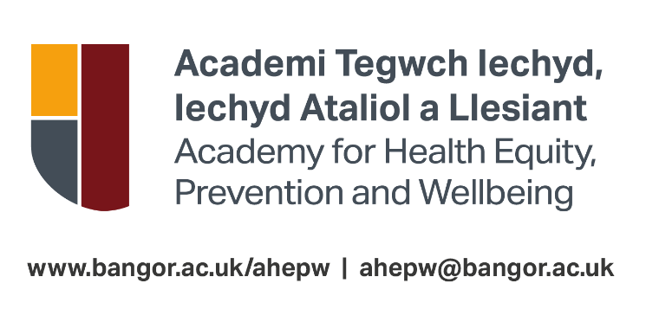
Academy For Health Equity, Prevention And Wellbeing
@Bangor University
UK Fee Scholarships in Prevention, Population Health, and Leadership
Eligibility, Allocation Process, Terms and Conditions and Application Form

1. THE PURPOSE OF THE AWARDS
Welsh Government wish to support professional learners in the NHS, Social Care and Third Sectors in Wales to undertake education and personal development in key policy areas and have established an Intensive Learning Academy programme for this purpose. Grant funding from Welsh Government allows each Academy to offer a number of generous scholarships for eligible applicants.
Part tuition fee scholarships worth up to £3,000.00 are available at Bangor University on the PGCert/PG Diploma/MSc Prevention, Population Health and Leadership programmes and some individual flexible delivery modules. There are limited number of scholarship places available, and these will be allocated in line with the criteria below.

If you would like to discuss making an application for a Scholarship, please contact ahepw@bangor.ac.uk

2. APPLICATION PROCESS
i. Students must follow the standard Bangor University application process. The awarding of a scholarship does not guarantee a place on an AHEPW programme or flexible delivery module, students must also submit a successful application for a place on the programme or module and meet all entry requirements. If a scholarship is offered, potential students must submit an application for a place on a programme or flexible delivery module here by Friday 09 August 2024, otherwise the scholarship may be offered to another candidate.

ii. Students can apply for a scholarship prior to submitting their application for a place on the programme.

iii. Students need to complete the application form below (Appendix 1) and ensure the statement of support from their employer has been completed.

iv. The award of Scholarships will be decided by the AHEPW Scholarships Panel and applicants will be advised of the outcome of their application within 10 working days of the application deadline. Those unsuccessful in securing a scholarship may apply for a place on the programme as self-funding learners or employer funded if they wish to do so. Information about postgraduate fees and finances is available here.

v. Applications for Scholarships must be made by Friday 19 July 2024. Applicants will be notified of the panel’s decision by Friday 02 August 2024.

vi. Students will not be paid the scholarship funding. The funding will be paid directly to their university account.

PLEASE NOTE: The Scholarship can only be used towards payment of the tuition fees and is non-transferable. Any extra costs that may be associated with any of the AHEPW programmes and modules are not included.

3. SCHOLARSHIP AWARDING PROCESS
i. Scholarships will be awarded by the AHEPW Scholarships Panel. The panel consists of the AHEPW Lead, Module Coordinator, Administrative Officer, and a member of Bangor University staff from another department within the University.

ii. Scholarships are awarded on the evidence of the greatest benefit to the applicant, their employer and the patients, service users or community that they support as well as contributing towards the outcomes of a Healthier Wales1. This decision will be based upon the evidence submitted in the application form from the applicant and their employer.

iii. The panel will agree in each funding round the exact allocation of scholarships in line with the amount of funding available. Funding will be allocated across full and part-time modes of study in line with demand and the quality of applicants. Scholarships will be allocated to reflect an intention to support learners from all targeted groups (Health care, Social Care, Public Sector, and the Voluntary Sector).

iv. Applications will be scored as set out in the application form at Appendix 1 below and ranked in each sector and scholarships allocated in line with the target groups above and the quality of applications received.

v. Applicants who are not satisfied with the decision of the AHEPW Scholarships Panel should contact ahepw@bangor.ac.uk in the first instance.

vi. Successful applicants of the Scholarship will be expected to provide a review of their course twice a year i.e. at the end of semester 1 and semester 2. They will also be expected to provide a final review on completion of their studies. Please note that details in the review may be anonymised and used for reporting and/or marketing purposes.

4. ELIGIBILITY
i. Applicants need to meet the entry requirements for a place on a relevant programme or flexible delivery module. Further information about the entry requirements can be found on the AHEPW webpages https://www.bangor.ac.uk/applied-learning-for-preventative-health-academy-alphacademy

ii. Applicants must be:
o Currently working with/for health care, social care, public sector and the voluntary Sector in Wales; and
o Have confirmation of support signed by their employer using the proforma provided; and
o A UK national or have 'settled status' (that means no restrictions on how long applicants can stay in the UK); and
o Living in the UK and Islands for the three years prior to the first day of the first academic year of your course.

iii. Applicants must be applying for a AHEPW programme or flexible delivery module commencing September 2024.

iv. Fee Scholarships are available to candidates applying for full-time or part-time programmes of study.

v. The Scholarships are non-means tested, i.e. will not depend on an applicant’s family income.

vi. Students who already have full or partial funding will not be considered.

5. TERMS AND CONDITIONS:
i. A scholarship partially covers the module/programme tuition fees as per the original application for that academic year. Part-time candidates have their tuition fee scholarship pro-rated to cover their fees over the duration of the programme.

ii. The completed scholarship application form (see Appendix 1 below) should be sent to ahepw@bangor.ac.uk

iii. The Scholarship will be offset against their tuition fee costs and successful candidates cannot receive the scholarship directly.

iv. Scholarships cannot be deferred; candidates must take up the scholarship by the date stated in the award letter.

v. Any scholarship offered to a candidate but declined prior to enrolment, will be offered to a reserve candidate. Candidates will be notified as soon as possible, however, candidates on the reserve list are advised to look at alternative funding options as there is no guarantee a Scholarship will become available.

vi. Scholarship holders will be encouraged to participate in University marketing and recruitment activities.

vii. A requirement of the Scholarship is that you complete2 your studies. Completion in this context constitutes the attendance at the entire course and completion of the required assessments.
Once awarded a Scholarship, if a student withdraws from their studies, the Scholarship will be cancelled in full, and the student may become liable* for full repayment of any scholarship amount already offset against tuition fees.
*Students who withdraw on basis of compelling personal reasons (for example, health, maternity) may not be liable for full repayment of Scholarship.

viii. If it is deemed necessary for a Scholarship holder to suspend their studies, the Scholarship will be adjusted pro-rata up to the start of absence and the balance of the scholarship held on University account and carried forward to the year of resumption of studies.

6. DATA PROTECTION
By applying to be a Bangor University scholarship student, Bangor University will be required to collect, store, use and otherwise process information about you for purposes connected with the application process and for reasons deemed necessary in order to take steps prior to entering into a contractual agreement with the University. Further detail on the type of information which will be processed can be found in the Privacy Notice for Prospective and Current Students on our website: https://www.bangor.ac.uk/governance-and-compliance/dataprotection/documents/Student-Data-Protection-Statement-Approved-October-2020.pdf
2 Completion in this context constitutes the attendance at the entire course and completion of the required assessments.

APPENDIX 1: APPLICATION FORM
Please submit your completed scholarship application form to ahepw@bangor.ac.uk by Friday 19 July 2024.

Part 1: Your personal information so that we can link this application to your programme application
Full Name:
Address:
Postcode:
Email Address:
Programme / Module applied for:
Date:

Part 2: How will the course benefit you, your organisation, and the patients / service users you work with?
Please tell us the sector, employer and setting in which you work and how your current role is aligned with the outcomes of this module/programme (Maximum 300 words – 5 points allocated)

How will your learning contribute to delivering the outcomes of a Healthier Wales? Maximum 300 words – 5 points allocated)

What impact will this course have for your organisation and service users? (Maximum 300 words – 5 points allocated)

PART 3: EMPLOYER STATEMENT
To be completed by the applicant’s line manager or relevant senior manager

Please discuss how your organisation will benefit from the learner’s participation on the programme and what impact you expect it to create. (Maximum 300 words – 5 points allocated)

Please confirm that the applicant will be supported to have sufficient protected time to undertake the self-directed learning required to complete the programme.
Signed by:
Name:
Job Title:
Date:
On behalf of (organisation name):

(https://gov.wales/sites/default/files/publications/2019-04/in-brief-a-healthier-wales-our-plan-for-health-and-social- care.pdf

