**Scholarship Examination in Economics**

**Answer 2 questions**

1. The graph below shows the Bank of England’s Official Bank Rate from 2007-2023:

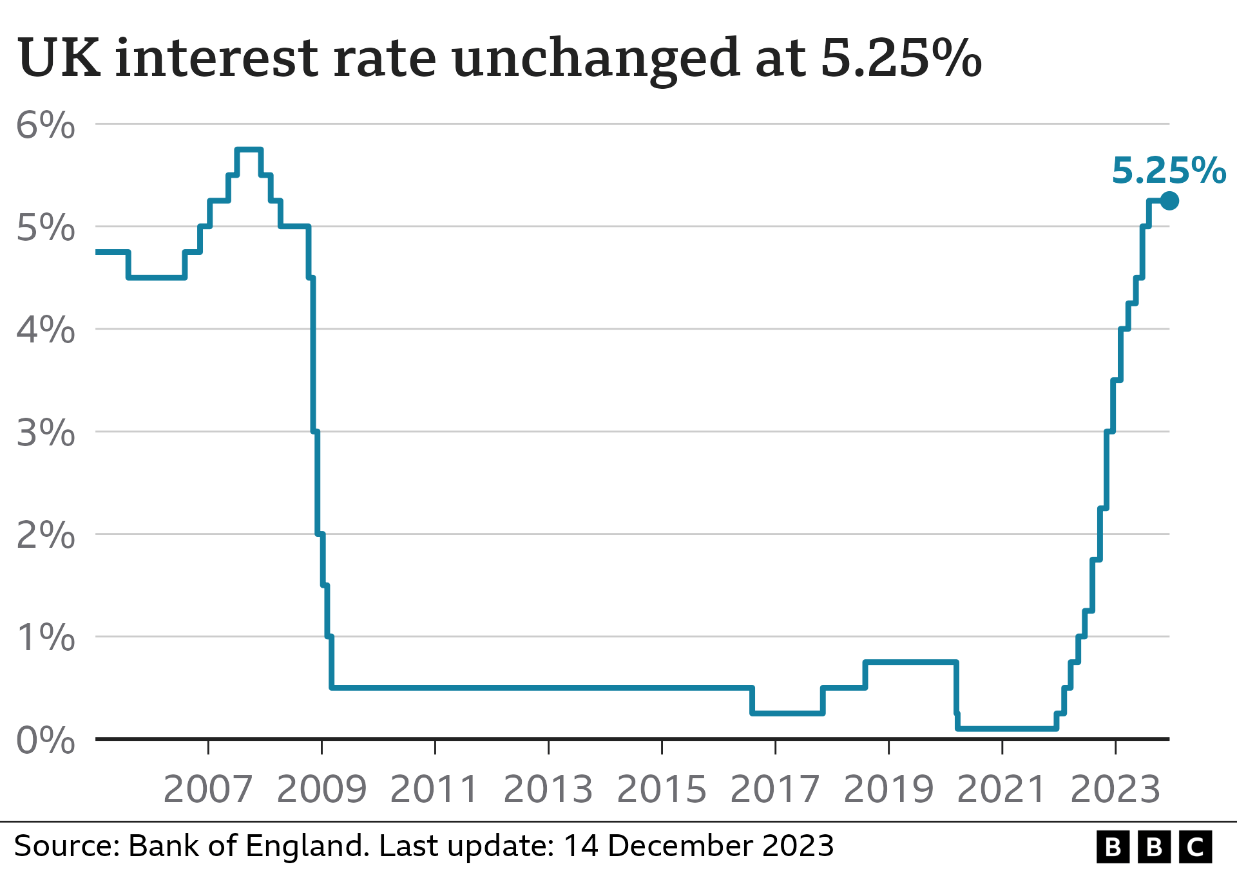

(Source: BBC)

Provide an analysis of the pattern of interest rates shown in the above diagram. In your answer, explain how interest rate changes impact the real economy and inflation and evaluate the effectiveness of interest rate changes as a monetary policy tool.

1. Discuss the economic rationale behind consumer subsidies. In your answer, refer to concepts such as consumer and producer surplus, price ceilings and floors, as well as merit and demerit goods. Provide relevant real-world examples.
2. Explain the economic problem of resource allocation and analyse how different economic systems may solve this problem. Use examples to illustrate your arguments.
3. Discuss the market failure of negative externalities in the context of the environment. In your answer, analyse policy options available to the government to deal with this market failure and assess their effectiveness using relevant examples.
4. Critically assess protectionist trade policies adopted by some countries. Analyse their impact on domestic economies and global trade using relevant economic models and examples.
5. Briefly explain the key characteristics of the different types of market structures (perfect competition, monopoly, monopolistic competition and oligopoly), providing examples of each one. Assess the role of competition policy in promoting efficiency in markets. In your answer, analyse policies such as monopoly regulation, mergers, and anti-competitive agreements.