# Opportunities for Master of Science by Research (MScRes) study at the School of Computer Sciences and Engineering at Bangor University

# Introduction

In this booklet you can find out more about current opportunities to undertake a self-funded Master of Science by Research (MScRes) degree at the School of Computer Sciences and Engineering, entirely focused on a research project of your choice.

The MSc by Research (MScRes) is a one-year full-time research programme (or 2 years part-time) that differs from a taught Masters programme by placing more emphasis on research, and by being examined much more like a PhD, by an internal and an external examiner, rather than by grading of coursework and dissertation. This degree will equip you with confidence and competence in the latest research skills (including generic skills such as literature searching, legal and ethical aspects, project planning, grant proposal writing, and statistical analysis of data) and allow you to apply for further research training (PhD) programmes, or to directly apply for research positions in universities or research institutes.

The list or projects in this document is not exhaustive; please feel free to contact individual members of staff whose research aligns with your own interests to discuss additional possibilities.

In addition to working on your research projects, as postgraduate researchers at Bangor you will have access to a range of research skills and professional development training opportunities as well as the chance to develop your teaching skills by undertaking paid demonstrating opportunities for modules on our undergraduate curriculum.

You will also present your work at the annual School and College Postgraduate Conferences and become part of the vibrant College research community. There are multiple research seminarsthat run across the three Schools within the College of Science and Engineering, and you’d be able to join any that relate to your research interests.

Successful applicants typically have a good first degree in a relevant subject (2:1 or above). While the minimum qualification that would allow you to apply for this programme of study at Bangor University is a 2:2, if that is the case we strongly encourage that you discuss your academic background with a potential supervisor before applying. If you have valuable non-academic experience that is relevant to your research plans, you may be in a good position to secure a place on this course, even if you do not have a First or a 2:1 degree from your undergraduate studies.

You would also need to have identified a way to fund your studies (tuition fees, bench fees, living expenses).

**How to apply:** The first step is to identify a project you are interested in then and contact the member of staff who is advertising it. They will then advise you if and how you should make a formal application to the University. When contacting potential supervisors, you should briefly outline your academic background and explain your interest in the project you are contacting them about, as well as attach a CV.

**Do not submit a direct application for a postgraduate research degree to Bangor University without first identifying a potential supervisor and discussing your research interests with them first.**

In addition to contacting the individual members of staff who have advertised specific projects here, you may also contact the following staff with general inquiries:

School Director of Postgraduate Research Studies (School of Computer Science and Engineering): Dr William Teahan ([w.j.teahan@bangor.ac.uk](mailto:w.j.teahan@bangor.ac.uk))

College Director of Postgraduate Research Studies (College of Science and Engineering): Dr Alexander Georgiev ([a.georgiev@bangor.ac.uk](mailto:a.georgiev@bangor.ac.uk))

# MScRes in Computer Science

<https://www.bangor.ac.uk/courses/postgraduate-research/computer-science-masters-by-research-mscres>

## Electronic Engineering

### Wireless sensor network for saline intrusion monitoring

**Subject area:** Electronic Engineering

**Supervisor(s):** **Iestyn Pierce** (https://www.bangor.ac.uk/staff/scse/iestyn-pierce-008384/en)

**Contact:** [i.pierce@bangor.ac.uk](mailto:i.pierce@bangor.ac.uk)

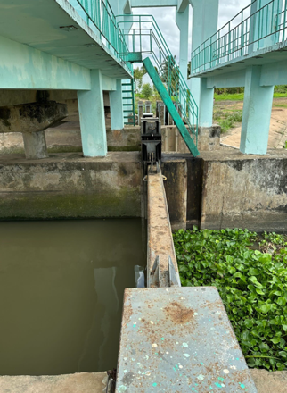**Project description:**

This is an exciting project for an electronic engineer to implement low power, long range wireless technologies such as LoRaWAN or NBIoT [ <https://doi.org/10.1007/s12243-020-00774-3> ] to construct a digital twin of irrigation channels for rice paddies in the Mekong Delta, Vietnam. The project will extend work on LoRaWAN for forest rainfall measurement to focus on salinity sensor technologies. The data provided should empower the farmers to make decisions for the good of their community facing saline intrusion in the Mekong delta. This project will be closely associated with the Agricademy agricultural and environmental technology initiative at Bangor University and linked with the only Fab Academy [https://fabacademy.org](https://fabacademy.org/) node in the UK. We seek self-funded candidates.

### Fabrication of Electronic Devices Using Micro-Fibrillated Cellulose (MFC)

**Supervisor(s):** [**Mohammed**](https://research.bangor.ac.uk/portal/en/researchers/iestyn-pierce(a8400cce-7568-49d7-84de-b231cd362ca7)/researchoutputs.html?ordering=researchOutputOrderByPublicationYear&descending=true) **Mabrook** (<https://www.bangor.ac.uk/staff/scse/mohammed-mabrook-016014/en>) , Graham Ormondroyd (https://www.bangor.ac.uk/staff/biocomposites/graham-ormondroyd-011501/en), Athanasios Dimitriou (https://www.bangor.ac.uk/staff/biocomposites/athanasios-dimitriou-046426/en)

**Contact:** [m.f.mabrook@bangor.ac.uk](mailto:m.f.mabrook@bangor.ac.uk)

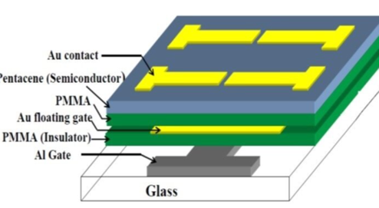**Project description:**

This project aims to demonstrate the feasibility of using micro-fibrillated cellulose (MFC) and keratin as the main insulator for future flexible electronics. The project will build upon previous work on using organic and bio-based materials for the fabrication of electronic devices such as capacitors and field effect transistors. The research will involve preparation of the nanoparticles and device fabrication in our class 1000 clean room.

Different disposition techniques will be used to deposit the thin films and surface morphology will indicate the quality of the films. Electrical characterisation of the fabricated devices will be used to estimate the efficiency of the new device structure. Student will be supported by academic and research staff.

### Asian Hornet Detection via Multimodal Sensing and Machine Learning

**Subject area:** Electronics Engineering/Artificial Intelligence/Ecology

**Supervisor(s):** Dr Cristiano Palego, SCSE, <https://www.bangor.ac.uk/staff/scse/cristiano-palego-094570/en>; Dr Paul Cross, SENS, <https://www.bangor.ac.uk/staff/sens/paul-cross-007630/en>

**School:** SCSE/SENS

**Project description:**

Asian Hornets (*Vespa velutina*) are an invasive species in the UK, threatening apiculture and native pollinators. They attack bee colonies, causing ecological and economic damage. Early detection is crucial but current methods are labour-intensive and error-prone. This project aims to develop an automated detection system using electrical and imaging sensors with machine learning. Multi-spectral sensing and advanced algorithms will ensure high specificity and accuracy. Field studies in apiaries will train and test the system, providing timely warnings to beekeepers. The research explores whether automated systems can enhance manual detection, supporting pollinator ecosystems and UK biodiversity resilience.