|  |  |  |
| --- | --- | --- |
|  | **MScRes Bursary Competition** |  |

**Deadline for applications: 5 pm, 30th April 2025**

The School of Environmental and Natural Sciences at Bangor University and the Friends of Treborth Botanic Garden are pleased to **announce 2 bursaries (of £2,000 each) to support self-funding applicants to complete a Masters by Research (MScRes) degree on topics of relevance to the mission of Treborth Botanic Garden**. The bursaries will partly offset the fees payable to Bangor University for the completion of the degree and are generously made available by the Friends of Treborth Botanic Garden.

Three projects are open for applications (see below).

**If you’d like to apply for one of them, please follow these steps:**

1. Contact the lead supervisor (by email) to discuss your interest in the project and your academic background.
2. Only one application per applicant is permitted (i.e. you cannot apply for two or three different projects).
3. Prepare your application consisting of:
   1. Current academic CV;
   2. Personal statement (500 words or less) outlining your background, motivation for pursuing a postgraduate research qualification, and your specific interest in the project you are applying for);
   3. The names and contact details of 2 academic references.
4. Email your formal application to the lead supervisor by 5 pm on 30th April 2025.

Following the closing deadline supervisors will select their top applicant and may or may not wish to interview you in the process. The winners of the two bursaries (chosen between the top applicants of the three projects) will be selected by an independent panel. Applicants and supervisors will be informed of the outcome by the end of May 2025.

**If you have queries about the application process, you can contact:**

Dr Alex Georgiev (College Director of Postgraduate Research Studies of the College of Science and Engineering) at [a.georgiev@bangor.ac.uk](mailto:a.georgiev@bangor.ac.uk)

**Further information**

MScRes in Biological Sciences: <https://www.bangor.ac.uk/courses/postgraduate-research/biological-sciences-mscres>

Treborth Botanical Garden: <https://treborth.bangor.ac.uk>

Friends of the Treborth Botanical Garden: <https://www.friendsoftreborthbotanicgarden.org>

## Investigating genetic diversity in the Great Orme berry (*Cotoneaster cambricus*)

**Lead supervisor**: Katherine Steele [k.a.steele@bangor.ac.uk](mailto:k.a.steele@bangor.ac.uk) (School of Environmental and Natural Sciences)

**Co-supervisor(s)**: Rosie Kressmann and Natalie Chivers (Treborth Botanic Garden); Robbie Blackhall Miles (Honorary Lecturer Bangor University & Plantlife Cymru)

**Project description**

*Cotoneaster cambricus* is a critically endangered Welsh plant species that is only found in the wild on the Great Orme, North Wales. No new plants have been established in the wild from seed and recent research suggests that the seeds need to experience prolonged frosts to break their dormancy. As the microclimate on the Great Orme does not facilitate this process, propagation from cuttings has been used in conservation efforts. This has increased the *in-situ* population from 6 to approximately 80 plants since the 1970s.

In 1999, the *in-situ* population was found to possess some genetic diversity with the DNA markers available at that time, but a more detailed genetic analysis is long overdue. Uncertainty exists as to whether the species can only reproduce asexually (through apomixis). Some morphological diversity has been observed in specimens grown *ex-situ* at Treborth Botanic Garden (TBG) and other botanic gardens, suggesting that out-crossing may be taking place, but this has not been observed in the wild population.

This project aims to estimate genetic diversity in *C. cambricus* and evaluate evidence for outbreeding to inform management options for conservationists. It will use current genomics tools to investigate the level, type and possible sources of genetic variation present by comparing samples from *in-situ* plants with samples from *ex-situ* plants, propagated both from cuttings and from seed at Treborth, and other botanic gardens where available. The student will allocate each plant specimen an accession ID and develop an inventory of available specimens available for the study. The student will be trained in horticultural techniques, DNA extraction and a range of methods for genomic analysis including relevant bioinformatics. The student will be encouraged to present the project to specialist groups and publish findings where appropriate.

## The state of Treborth’s moths – leveraging long-term moth recording data to identify trends in moth abundance at Treborth Botanic Gardens

**Lead supervisor:** Dr John Mulley ([j.mulley@bangor.ac.uk](mailto:j.mulley@bangor.ac.uk)), School of Environmental and Natural Sciences

**Co-supervisors:** Dr Darren Parker (School of Environmental and Natural Sciences) and Dr Colin Harrower (UK Centre for Ecology and Hydrology)

**Project description**

Many insect species are declining globally, and although “insectageddon” may not be imminent, there are clearly serious challenges to many species. The UK has one of the best long-term datasets in the world for tracking insect abundance in the Rothamsted Insect Survey, which has evidenced a 50-year (or more) decline in moth species, as well as a general North/North-West range shift. However, these large-scale national analyses often miss smaller-scale local trends, with implications for the adoption or alteration of management practices that may improve habitats for at-risk species.

Treborth Botanic Garden has operated a regular moth trapping and recording project for several decades now, and the data has recently been digitised. We can therefore utilise these data for analysis of long-term trends in the Garden for the first time.

In this project, the student will analyse the Treborth moth data to generate flight curve models which can account for gaps and missing data for each species, and then use these to: identify long-term trends in species abundance; determine climate-induced shifts in first appearance or highest count dates; and to identify species which have been gained or lost. The Treborth data will also be compared to the wider UK or England/Scotland/Wales datasets to identify species for which the Garden may be a particularly important refuge, and the student will then work with staff and volunteers to identify important habitat and/or foodplants that should be conserved or developed.

The student will also have the opportunity to perform capture-mark-recapture and population genetic experiments to better understand the structure of the Treborth populations of any particularly interesting (or threatened) species.

## Nature's Symphony: exploring the wellbeing benefits of directed listening

**Lead supervisor:** Whitney Fleming ([w.fleming@bangor.ac.uk](mailto:w.fleming@bangor.ac.uk), School of Environmental and Natural Sciences)

**Co-supervisor(s):** Tyler Hallman (School of Environmental and Natural Sciences)

**Project description**

*Rationale and Research Questions*

Studies exploring benefits derived from nature are dominated by the effects of visual stimuli, yet engagement with the natural world involves multiple senses. This project will explore how aspects of soundscapes and directed listening influence wellbeing in nature. Specifically, we will ask:

(1) How does the composition of soundscapes containing both natural and anthropogenic components affect wellbeing?

2) Does directed attention toward specific elements of soundscapes influence wellbeing?

*Methodological Approach*

Text Box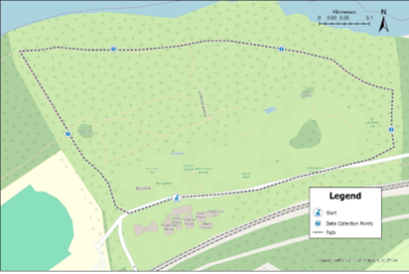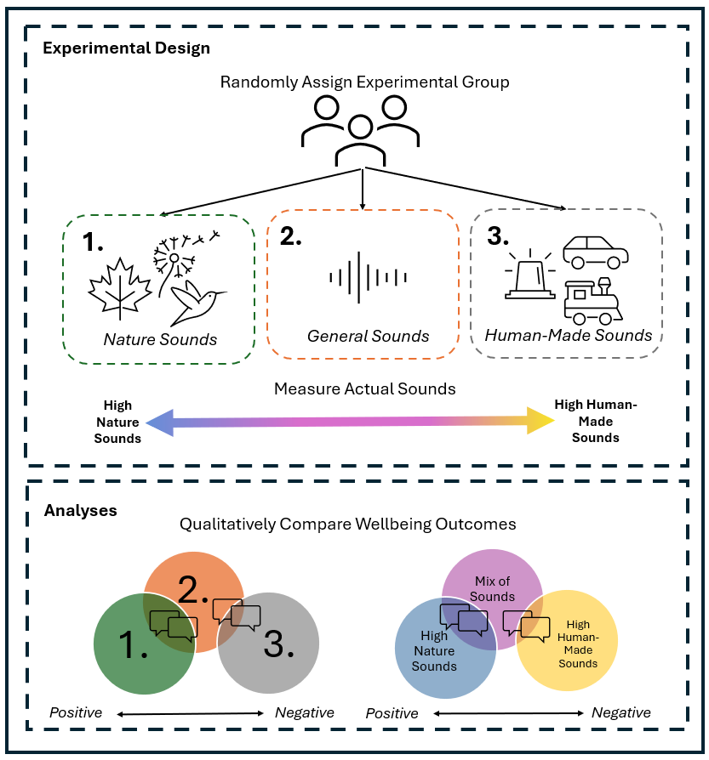

Text Box

The student will conduct experimental trials where participants are taken on a structured walk through Treborth Botanical Garden and instructed to focus on soundscapes (Figure 1). Using an experimental design modified from Fleming et al., 2024, each participant will be directed at the beginning of the walk to pay attention to either 1) natural sounds, 2) anthropogenic sounds, or 3) sounds in general (Figure 2). The student will assess the wellbeing outcomes of the walk for each participant using qualitative interviews. How participants describe their experience will be coded using thematic analysis and compared for each experimental group. During the walk, recordings will be taken to characterize the real auditory environment using acoustic indices that capture and differentiate between anthropogenic and natural sounds (e.g., Kasten et al., 2012; Boelman et al. 2007). To assess the relationship between perceived soundscapes and real environmental conditions, qualitative responses will be compared between treatment groups and between participants experiencing similar real-world soundscapes based on recorded audio. As part of a larger study, wellbeing outcomes will also be assessed through close-ended survey questions and physiological measurements that the student can use to inform their findings. Findings from this study could inform urban green space design that enhances sensory experiences and supports nature-based mental health interventions.