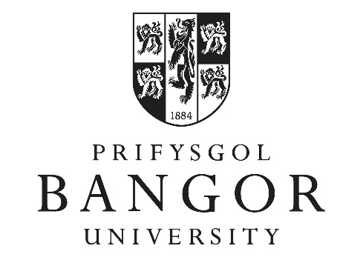
BANGOR UNIVERSITY

SPORTS SCHOLARSHIPS

Guidelines for applicants

Bangor University offers Sports Scholarships to recognize and support sporting excellence and achievement. They are aimed at helping talented and high performance students to combine their academic study and sporting performance to assist them in achieving their full potential.
The scholarship programme is part of a wider commitment to raise the profile and reputation of the University through sport.

Applications are not limited to any particular sport or to students on any particular course but applicants should note that in most instances, preference will be given to those individuals who will represent the University in British University and Colleges Sport (BUCS) competition framework. A full list of BUCS sports is available on their website at: http://www.bucs.org.uk/
Exceptional applicants (those regularly competing internationally) in non-BUCS sports should still apply.

The maximum value of a sports scholarship will be up to £3,000 a year. The scholarship should be used to aid the performance of an athlete and operates on a “claim back” basis for expenses incurred in relation to competition or training.
Applications will be received and awarded annually and can be made during any year of study at Bangor.

To be eligible for consideration you will need to be:

- Likely to achieve a podium, or points scoring position at the appropriate BUCS championship.
- A European, Commonwealth or World level competitor in their chosen discipline
- Not receiving significant commercial sponsorship
- Have no history of disciplinary or doping infractions in any sport

The following additional criteria will assist the Sport Scholarship Panel in evaluating applications:
  - Likelihood of BUCS points, particularly for sports with individual championships
  - Level of support/expertise available at Bangor
  - Period of study at Bangor
  - Availability of training facilities and equipment at Bangor.
  - Perceived positive impact that funding will have on performance
  - The overall costs of participation in the sport
  - Likelihood of performance improvements during the period of study
  - Willingness to sign and conform to the Bangor Anti-Doping agreement
  - Strategic partnerships in place with the relevant NGB
  - Athlete willingness to represent Bangor in public – including non-sporting activities such as open days, school visits and similar.
  - Level of athlete profile in their sport and the wider community
  - Any other factors deemed relevant by the panel

Application Timelines
Two application windows will operate – one for incoming students and one for existing students or those that arrive through clearing or other later entry.
For incoming students, applicants will be received prior to 31st March in the year of entry.

For returning or late entry students, applications will be received by 31st October in the current academic year.

Application forms should be sent to
Iona Williams
Canolfan Brailsford, Ffriddoedd Road, Bangor. LL57 2EH
Tel no: 01248 382571/e-mail iona.williams@bangor.ac.uk

The decision to award the Scholarships will be taken by the Sports Scholarship Panel.
Their decision will be final.

